Bubbles, no Troubles
Team 1

Problems and Challenges
- Challenge to kickstart the 1st Plan Layout Iteration
Assume the design team already figured out the SOA (Schedule of Accommodation), the list of Rooms, and all the numbers and figures required for the layout to work, yet it still took way too long to come out with a more-or-less feasible plan layout.
So, why is there this “mental block” which prevents the designer from jumping into the action straight away?
- To Overcome the Inertia
From “nothing” to “something”, the first step is always the most difficult one.
What if a programme/script is able to generate a workable bubble diagram (or a few) to kickstart the design exploration?
- Stop Second-Guessing Your Every Decision to Place A Room
In terms of human thinking logic, our train of thought tends to be “linear”, i.e. one item after another. In space planning, one room after another - without the overall picture.
Instead of keep asking yourself “where shall I put the next room?”, would you consider just “roll the dice”, and see what the “overall picture” could be like? Then pick one and develop further from there.
- Hand-sketched Bubble Diagram usually not scaled
Bubble diameters can be parameterised, hence this small issue can be easily overcome.
- Relationship Between/Among the Spaces Often Overlooked (Critical)
This is a topic of Domain Expertise, particularly on Space Adjacency & Segregation. Certain rules-of-thumb, COP are usually only known to the experienced space planner (e.g. Medical Planner) . The team aims to find means to establish and quantify such Relationships, and feed the info to the script to generate the layout bubble diagrams.
- Be the Judge, Instead of Being Judged
Even the most experienced designer, would feel not confident about his initial judgement, at times. It is time to take a more relaxing role of judging and commenting on the works of the automation process, instead of your own.

Objectives and Impact
- Agent-based Simulation, using Physics Engine (Kangaroo 2 in Grasshopper, Rhino);
Chat-GPT to assist in generating Python Scripts for custom-made GH Component;

Solutions and Tools
- Plan the Solution Approach with Schedule of Accommodation (SOA); List of Room Relationship (Template will be developed by the AI Hackathon Team)
- Current AI Tools (Generative AI) are mainly focusing on output formats on Texts, Images, or even Videos (moving pictures). As of now, there is no AI Tool available to deal with Physics Properties (say, Charged Particles).
- Grasshopper is chosen, in view of its versatility, and its Plugin, Kangaroo 2, as the Physics Engine.
- However, in Kangaroo 2, it is possible to simulate the physics properties like gravity, tension, collision, etc; however, electrical charge is not among the list. Hence, custom-made grasshopper with embedded Python/C# scripts shall be created.
- ChatGPT is hence the most crucial tool to fill in the gap, which takes the request in Natural Language (English) form the team, and translate into Python/C# scripts.
- ChatGPT will serve as a virtual team member with exceptional coding skills, who not only generates the programming scripts, but also assists with the debugging.
- Step-by-step approach
1. Define the Floor Plate Size, with a Closed Polyline;
2. Populate particles (points) based on the number of Spaces in the SOA;
3. Based on the Spreadsheet, assigned corresponding “electrical charge” to the particles;
4. Let the simulation begin, wait until the “equilibrium state” is reached;
5. Generate the bubble diagram based on the Charged Particles locations.

Limitations and Strategies
- The “Digital Analogue” (oxymoron) is based on an over-simplified model. The outcome, by no means, would be the perfect solution, or most ideal one.
- No model is perfect. But that doesn’t stop it being useful. Better results could be obtained by “brute force” trial-and-error for a few more rounds.

Tests and Measurements
- The team will leverage on the teammates’ past project experiences, and give a try on an imaginary healthcare project floor (say, a Polyclinic Floor, focusing on Consultation Units)
- The test case won’t cover all scenarios, but its logic will.
- Time, productivity, and manpower can all be translated to $.
Quality, on the other hand, is a bit more subjective, hence is open to interpretations.
- Benchmark against the current practice, on the timeline to generate the 1st layout plan for discussion. Knowing this amount of prep work is done before-hand, to calculate the ROI (return of investment) on time, and the future savings.

What Next
- Now with Rhino.inside.Revit, this workflow is also possible to be integrated directly into the Revit environment, bypassing/avoiding the interoperability issue altogether.
- Research paper(s) published in CAADRIA suggested some workflow to translate 2D graphics (i.e. conventional bubble diagram) into floor plans, via Deep Learning and Conditional GAN – which can be explored after this AI Hackathon.
- GenAI / ChatGPT can continue to be the virtual MVP to guide/assist the team to further develop this digital workflow, into a proper tool, say, macro, executable file, or a plugin with even clearer User Interface.

Documentation and Records:
https://drive.google.com/drive/folders/1a6TDwJO_DVy7VsbLaF9rD__K5WtRi9su?usp=sharing

CORENET X Compliance Checks
Team 2

Problems and Challenges
Architects find it challenging to extract and compile an accurate list of regulations from the various government agencies that are applicable to their project at the beginning of the concept design phase.

Extracting, compiling and interpreting the highly disparate and numerous regulations typically takes two to three days for a single designer. It is very important for this list to be accurate, precise and harmonised across the different agencies because if there is unresolved ambiguity because of competing requirements, change in regulations, emerging building types or human error, a large amount of extra work can be generated in later stages of the project. Especially with the evolving submission procedure, wrong information will result in wasted work if simple compliance is not met.

Consider the following example:
A designer documents an incorrect value for a site setback because the project involves a building type that is different from the land use. This problem is surfaced only after concept design has been concluded. The Architect then petitions URA (Urban Redevelopment Authority) to reconsider the use type in order to maintain the initial setback values used. If the setbacks must be changed, the project will need to be redesigned to accommodate the new setback. This process can take a month for a team of three Architects to redesign and redo the BIM model.

Objectives and Impact
- Allow Architects to generate an accurate, precise and complete list of regulations from different authorities for a given site instantly.
- The typical process takes three days for a single designer.
- Inaccuracies or evolving requirements can generate a substantial amount of extra work, resulting in increased costs to stakeholders involved.
- This tool will enable Architects to complete the compilation of regulations in minutes ensuring reliable up-to-date results that are harmonised across government agencies as codes are web-based nowadays.
- Solving this problem at the beginning of the design phase will avoid the need for compliance checking tools downstream, potentially saving months of work.

Solutions and Tools
A tool in the form of user-friendly GenAI ChatBot using natural language that allows Architects to generate an accurate, precise and complete list of regulations for a given site instantly.
- The regulations should be harmonised across multiple government agencies.
- Errors or ambiguities should be called out for users to seek further clarification.
- Regulations should be up to date.
- The list should be formatted, indicating the government agency involved, link to the source and date updated.

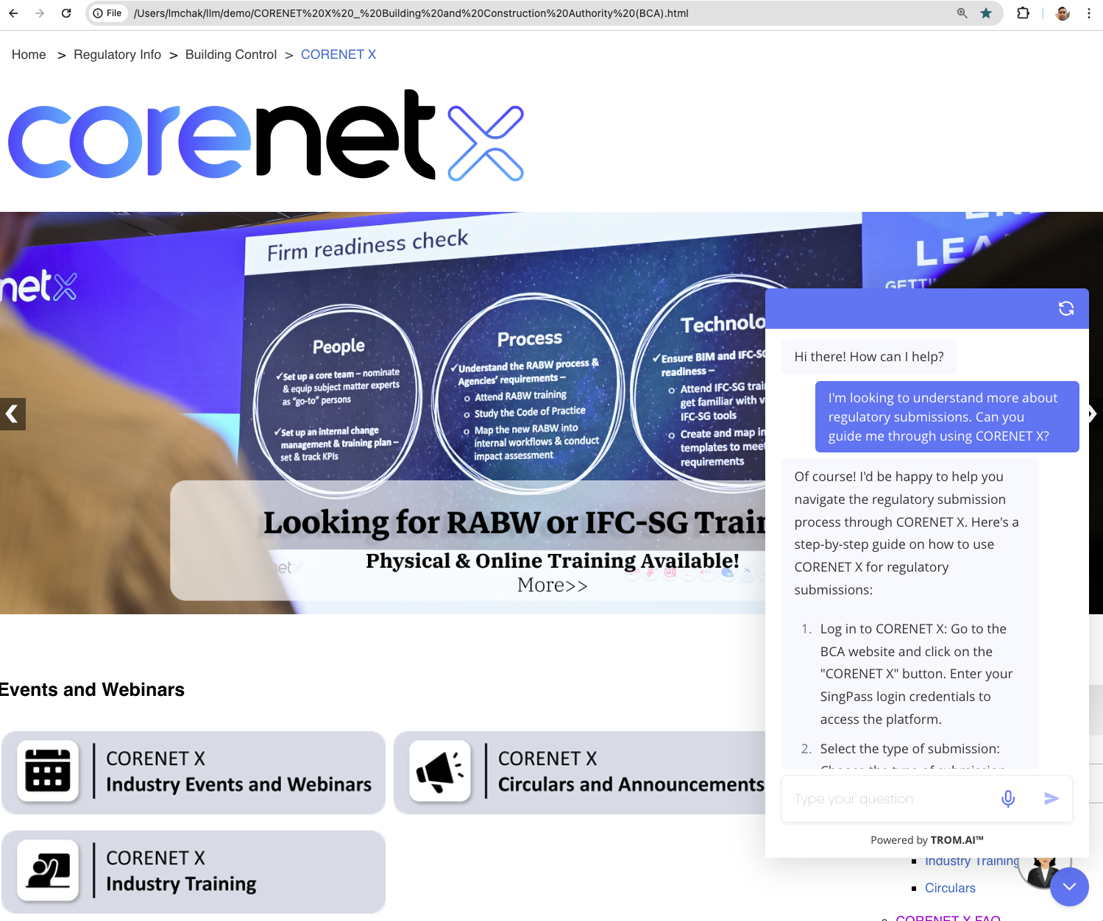
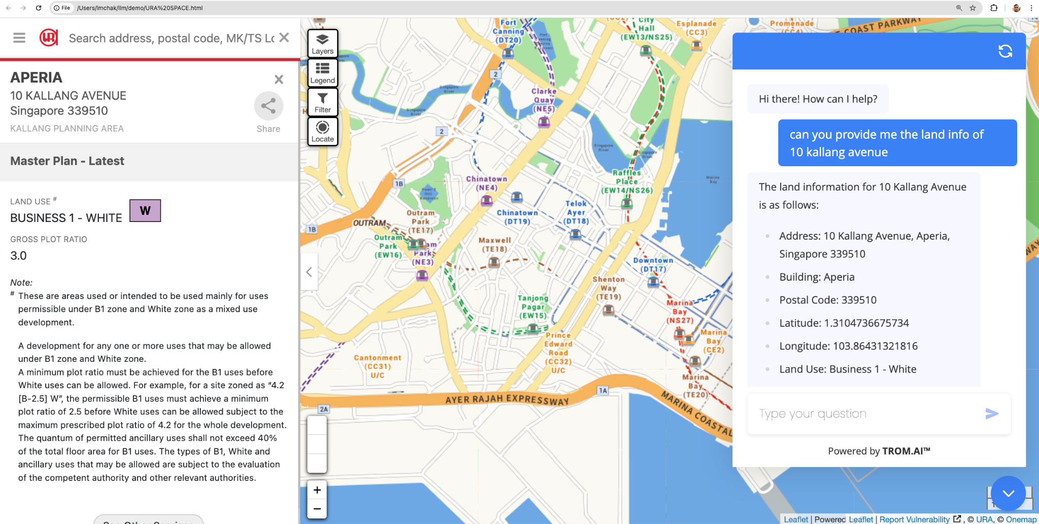

Solution Components
- GenAI Model Knowledge Base and Fine Tuning:
- Utilises CORENET X rule, Agencies Code of Practices and reference data parameters for RAG knowledge base creation.
- Utilising LLM Model to understand various compliance and submission requirements.
  - User Input Integration:
    - Allows customization of AI outputs to meet specific project needs.
  - Generative Compliance Process:
    - Employs AI to create a range of compliance requirements and responses.
  - Retrieval-Augmented Generation (RAG):
    - Incorporates RAG to enhance AI responses with external knowledge from an extensive regulatory and technical knowledge base.
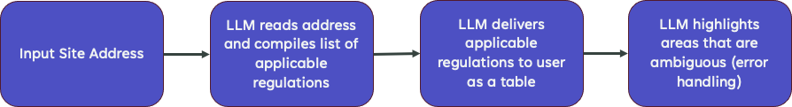
Tools
- LangChain, Vector Database, LLM, and others.
- RAG: Implementation of Retrieval-Augmented Generation for improved context and factual information retrieval.
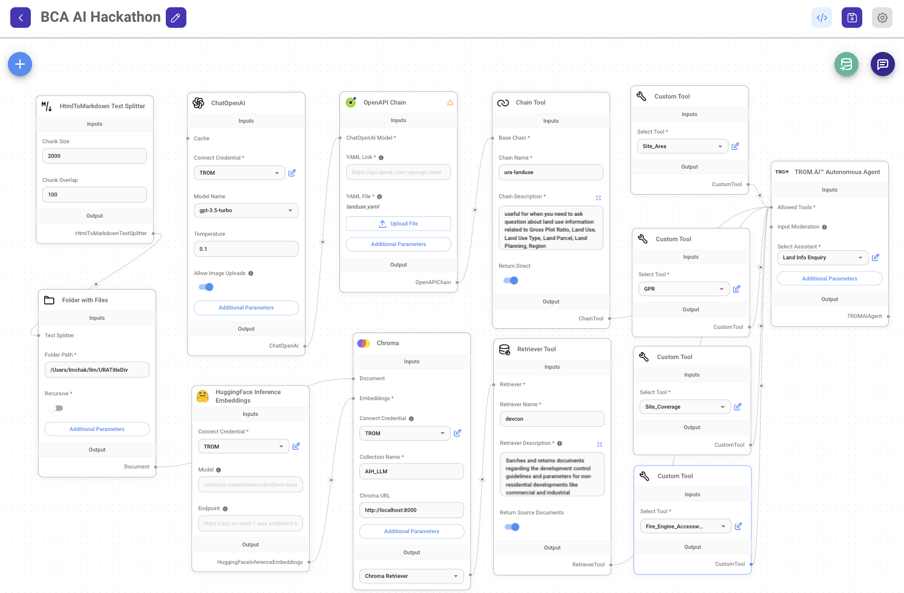
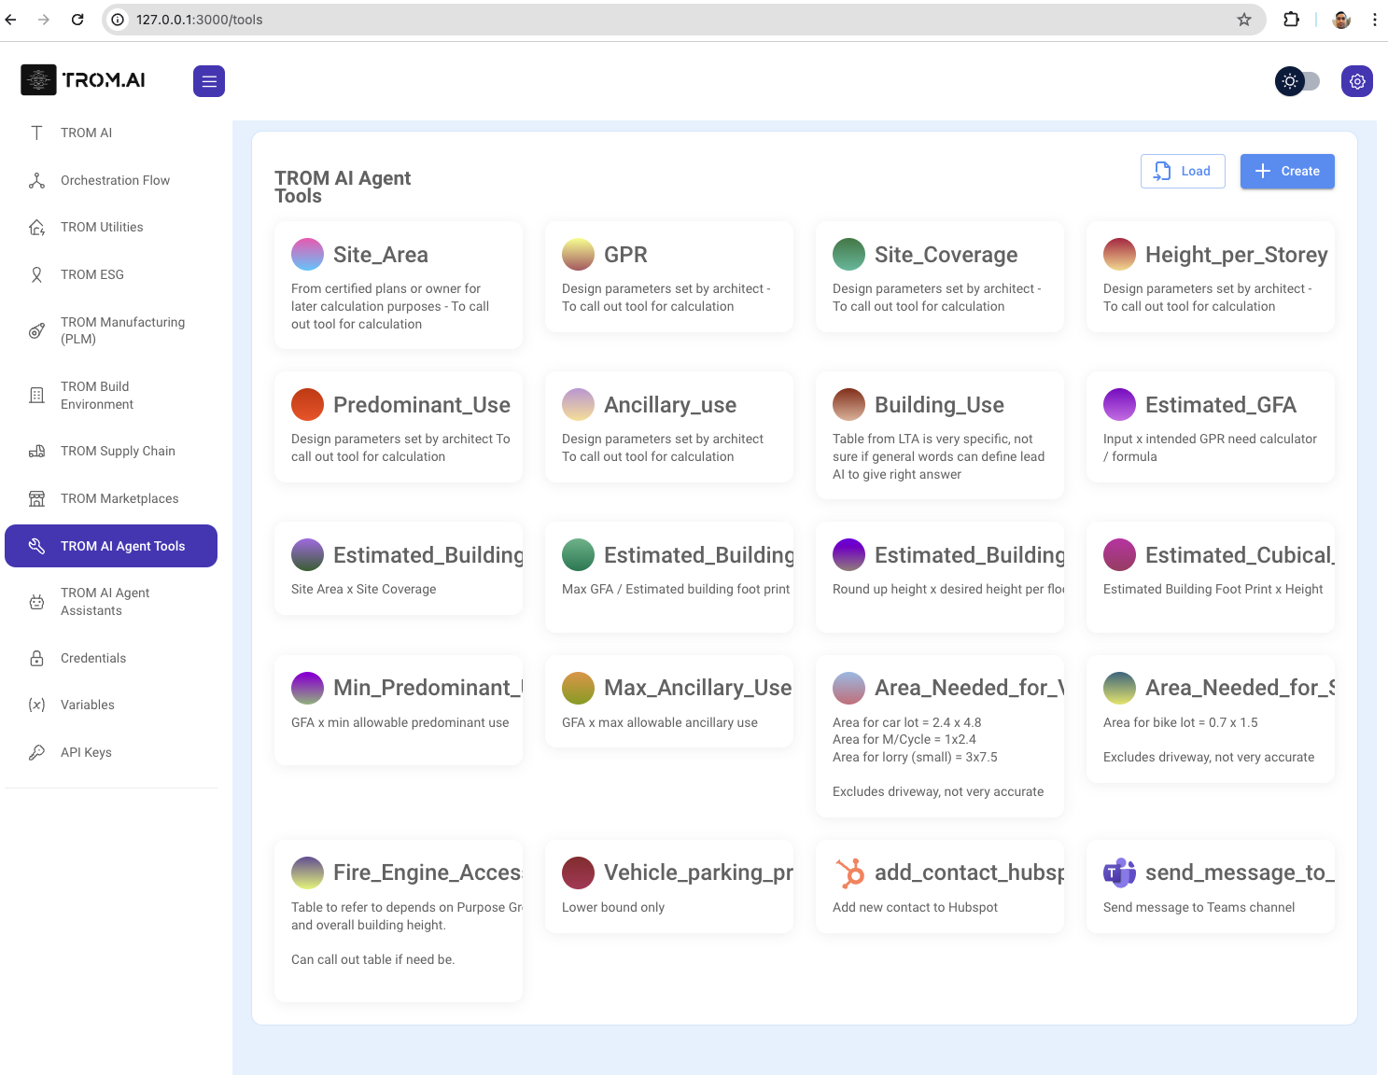

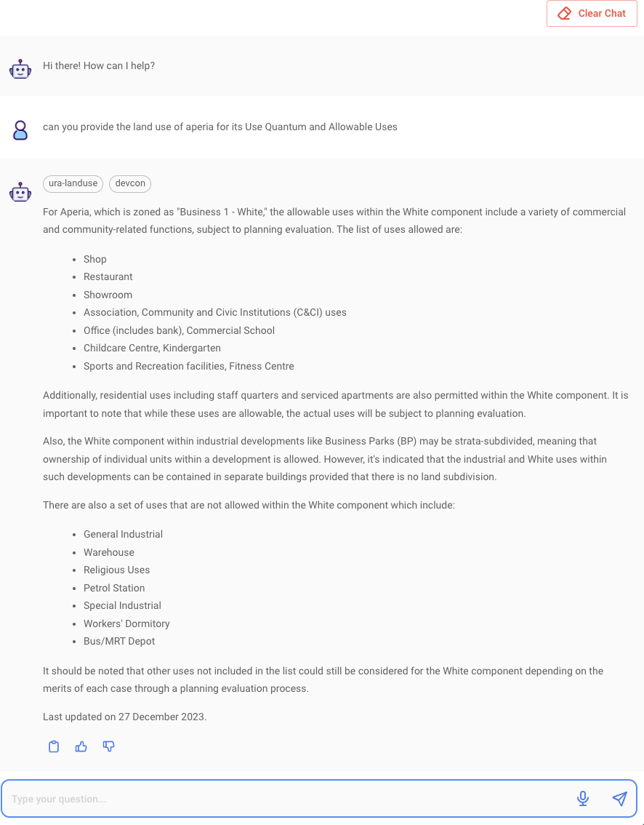
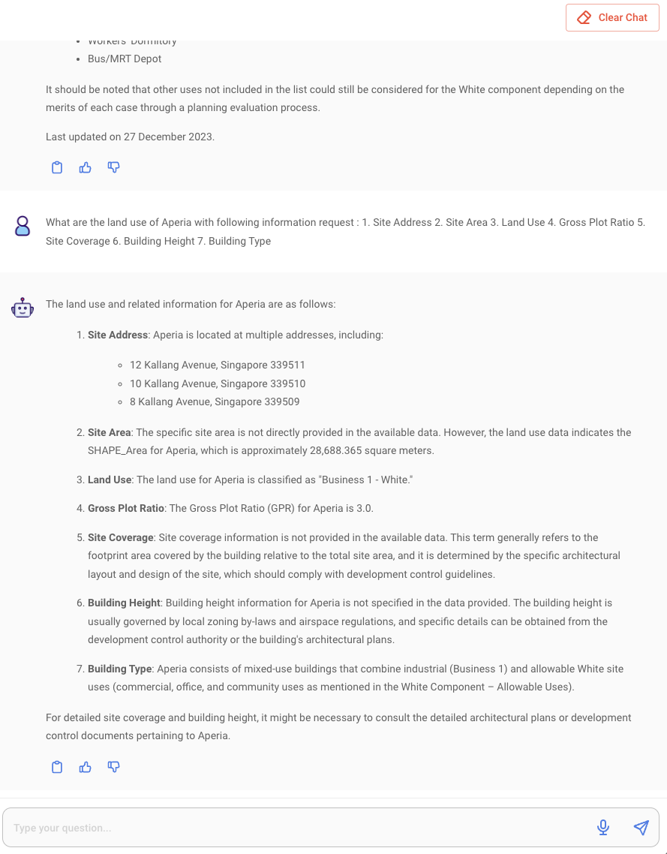
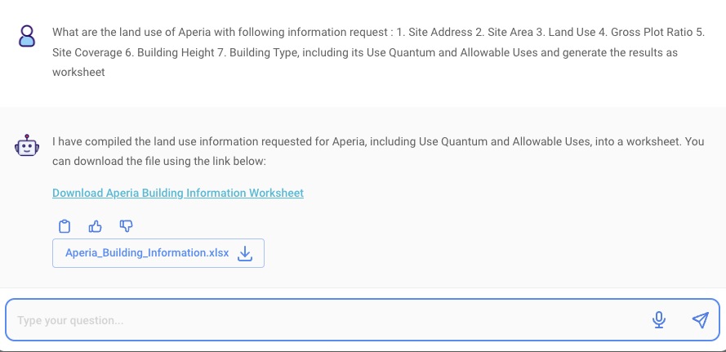

Limitations and Strategies
Challenges
- AI model interpretation of Authorities code requirements.
- Complexity of measurable BIM (IFC-SG) parameters, CORENET X rules, and regulatory requirements.
- Cross-agencies workflow and non-compliance checking.
- Cross-agencies code of practices data ingestion
- New Challenge: Integration of external knowledge using RAG.

Strategies
- Reiteration of the three components (AI Model Fine Tuning, Knowledge Augmentation, and Generative Process).
- Incorporation of RAG to address knowledge limitations and improve response accuracy.

Tests and Measurements
Control test (manual checking typically done by Architect)
- Test problem is crafted using 3 agencies as the base and identifying the information that can be retrieved by inputting just a site address.
- The ideal information retrieved have significant influence to the design although generic
- Information under URA Space is consolidated but hidden under many tabs and easy to miss
- There is no direct linkage to the subsequent chapters based on the use type and information has to be retrieved by searching through the code for the relevant clause to the site based on typical usage
- Every authority is on a different site and missing information is easy.
- Key output from the parameters generated will lead to further design considerations.

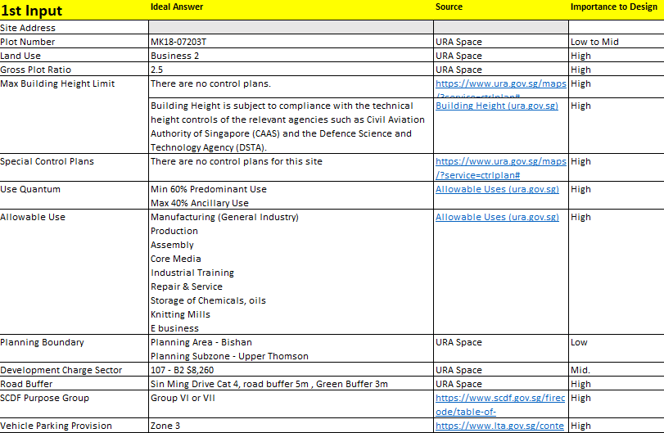

Prototype
- User accesses LLM to begin the Concept Design Stage
- User inputs site address, project type (building name)
- LLM generates list of requirements from 3 government agencies (URA, SCDF, LTA)
- 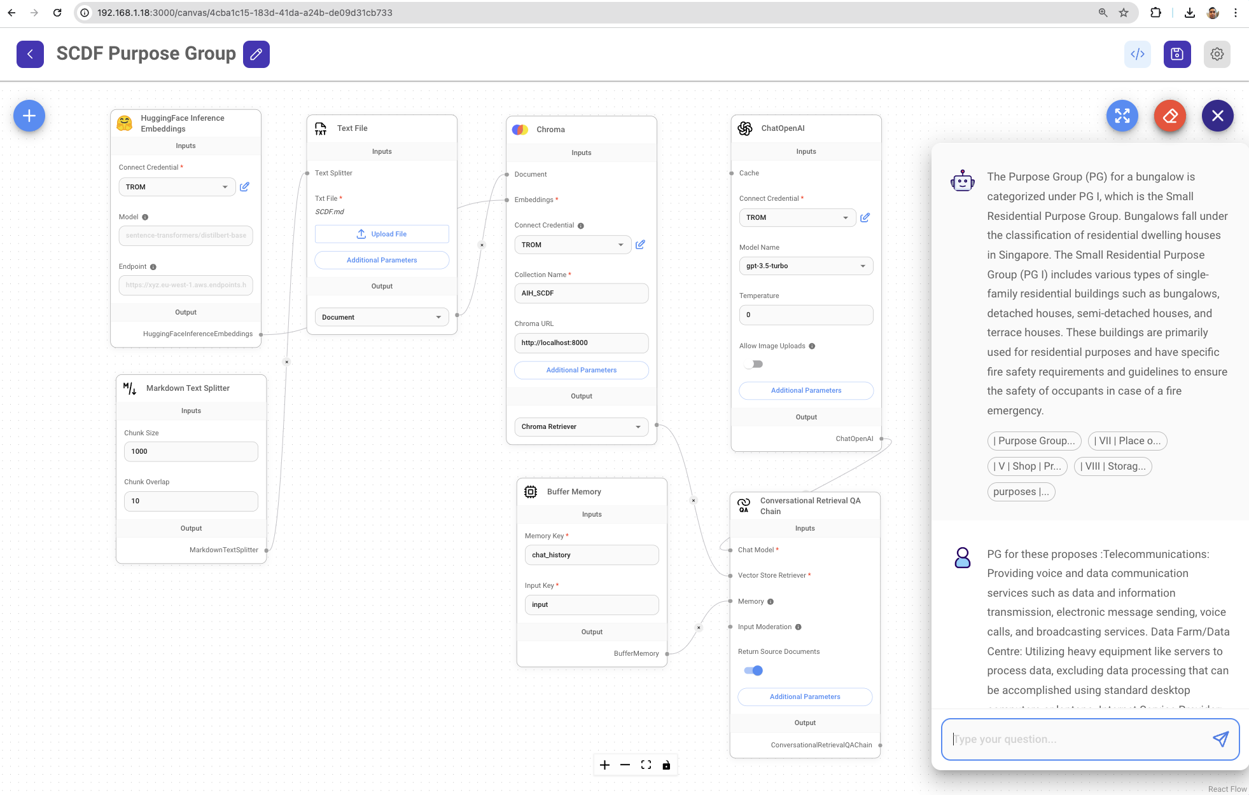
- 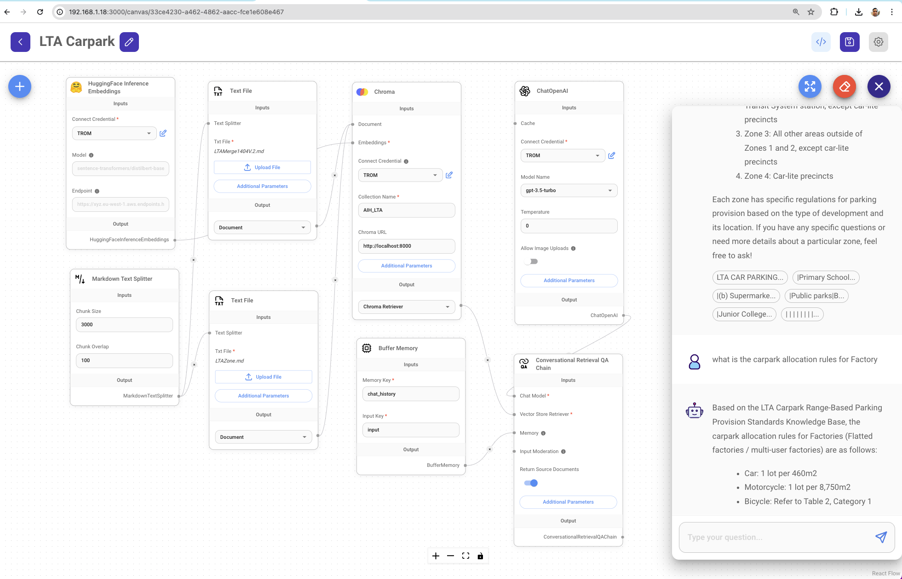

- LLM highlights ambiguities for Architects to seek clarification from the relevant agencies **
- User retrieves table and starts designing
Success Metrics
- Amount of time taken to generate the list of requirements
- Accuracy of requirements
- Completeness of requirements (based on fine-tuning data)
Enhancements
- Reduced option engineering time, providing faster compliance and tender submission.
- New Enhancement: Evaluate the impact of RAG on response accuracy and speed.

What Next
Expansion and Scaling
- Developing LLM to have capabilities to generate answers based on more complex inputs.
- Leveraging on retained knowledge to draw on tools for calculation purposes.
- Potential to expand AI capabilities with RAG to address more complex and diverse compliance requirements.
- Exploration of RAG's role in handling multi-objective submission approaches.
- Discovery with government agencies to validate assumptions that they are potential customers, apart from consultants.
- Adapting model for deployment across multiple regions.
User Feedback
- Robust user feedback mechanisms for continuous enhancement, now including RAG-related feedback.
Advanced Techniques
- Exploring advanced AI techniques such as multi-modality model, mixture of experts (MOE), autonomous agents, deep learning, predictive modelling, and further integration of RAG for continuous innovation.

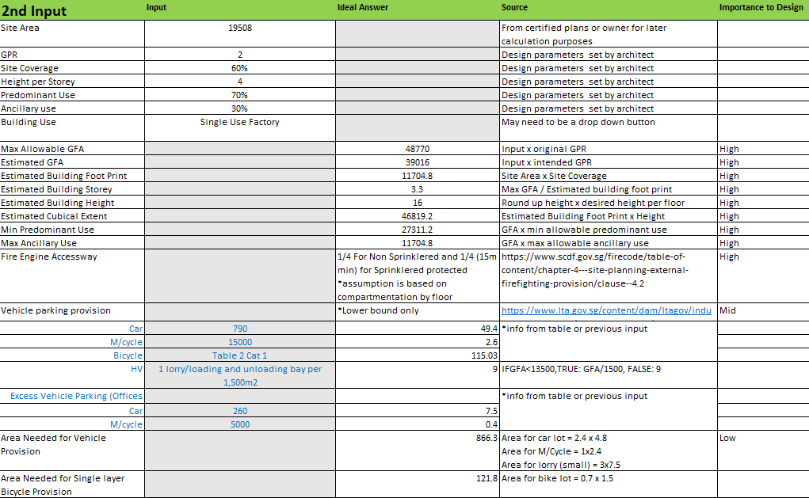
Example of more complex inputs to get ideal answers.

Documentation and Records
- Comprehensive documentation and resources available on GitHub.
- Expanded documentation on the implementation and impact of RAG within the solution framework.

FSSD Requirement & Compliance Checks
Team 3

Problems and Challenges
There is a huge amount of effort and time needed to comply with the fire code compliances.
The checks are not only laborious, it is also prone to human error and the efforts done for the checks cannot be claimed as an additional cost.
Computational methods to automate this process are not of linear complexity and may require many hours of computation to solve. As such, as a start, we determined the need to use AI and Machine Learning to automate the checking and placement process of Fire Extinguishers

Needs: To create a program to run the checks and identify locations of FSSD items to be placed on plans.
Platform to be used: Revit

Objectives and Impact
Our Team intends to create an AI application that is able to identify the locations of the FSSD items to be placed on plans. The checks will also serve to highlight any errors or discrepancies of non-compliances.

Scalability: It will be able to apply to any plans for easy compliance checks, and the application will be able to serve multiple users at the same time as solver logic is developed as an API server. The same paradigm may also be applied to other checks and placement workflows such for Fire Hydrants, Fire Hosereels, Risers, Fire Access Panels and so on.

Innovation: The current market does not provide for any accurate checks, all checks are done manually. Automating this function will not only reduce human errors, but also save the time needed and translate it into BIM, allowing for the recovery of design hours.

Impact: It will potentially change the way Architects and Technical managers work, providing more time and effort spent on coordinating other matters instead of focusing on highly repetitive compliance technicalities.

To summarise, our team has developed a Revit Plugin that allow automating the compliant placement of Fire Extinguishers for a given floor plan represented in Revit, and also allows for automated checking

Solutions and Tools
The tool can be a plugin to Revit and can be installed easily on Autodesk Revit. Data required would be the existing methods, obstacles and checks currently manually done that will be needed to compute in our digital tool.

The process will be as such:
Perform and understand all existing checking methods which are currently performed in our day to day FSSD authority checks.
- Identify potential obstacles which will taken into account when developing our digital tool
- Iterate and test the digital tool / plugin on any plans to verify accuracy and effectiveness
- Update and improve on the existing tool to minimise errors
- Create the plugin to be installed on the revit on companies as a beta test and market it as a MVP
- Continue to improve based on market feedback and response
- Launch the product for mass market distribution

Limitations and Strategies
Possible limitation would be the time needed to develop the digital software.
There could be limited data (data scarcity) to test the software on as well, due to the need to test it on various floor plans.

One strategy is to assign people to develop complex floor plans for testing, or to obtain existing floor plans in the public domain for the tool to be tested on.

Tests and Measurements
Tool will be tested on various plans, both existing and newly created. Measurable criteria includes:
- Time – our tool vs manual checks
- Cost – our tool (cost to maintain) vs labour cost to check
- Accuracy – our tool vs manual checks
- Manpower – our tool vs number of people needed for manual checks
- Productivity gains – measure in time spent using our tool vs human hours

We aim to have our digital tool to be the better option in all criteria that have been set out for.

What Next
The potential for this tool is immense as it is scalable in size of the plans, adaptable, and could be iterated upon further to be used for other compliance checks.

The MVP will be created after our internal checks and it shall aim to have an accuracy record of 99% alongside ease of use.

Documentation and Records:
Github for version control: https://github.com/boblyx/fire

Presentation Slides:
Gp3 -TEAM FIRE - Presentation.pdf

Layout Optimisation for Residential Feasibility Studies
Team 4

Problems and Challenges
During feasibility study for a residential project, the Architect usually organises house units around a central lift lobby core and corridor to gain the most optimised typical floor layout. The unit mix is usually provided by the Developer's marketing team, to which the Architect will run tests on typical floor layouts to check if this unit mix, or another unit mix that is adjusted and reproposed, can indeed achieve the most optimal efficiency for the development. An optimised efficiency and layout generally translate to greater profit for the development.
The current method is a manual operation utilising excel and CAD to test out various efficient layout configurations. This requires a significant amount of time, manpower and experience to achieve the best mix of units and typical floor layout. The manual method is not able to immediately work out what unit mix and typical floor layout to best meet the optimised efficiency. It may not even be achieved without computational assistance, which is able to test out all possibilities. Wrong assumptions during the manual testing phase or client-requested changes often lead to abortive work.

Objectives and Impact
The aim is to automate the testing of unit mixes and typical floor layout for optimum building efficiency. The platform would generate proposals that fulfil a desired range or level of efficiency. With rapid iterations of a large learned data set trained by residential experts, past projects and code requirements, optimised proposals shall be achieved with higher accuracy and speed. Unlike manual testing, abortive processes will be greatly reduced, and if re-testing is required, it is convenient and quick to do so on the platform.
Impact upon Developers and Architects would be large– users of varying experience in residential design can conduct feasibility study on the platform, which is a controlled environment for users to effectively manipulate and compare typical floor plan designs and unit mixes. Cost and time reduction due to savings in manpower can be achieved, and the quality is achieved through higher accuracy in producing configurations of optimised design.
Ideally, a working platform with a user-friendly interface will be created– this allows the Architect to conveniently key in Client’s brief, authority requirement etc. The platform would contain information on latest code requirements (data to be maintained by Architects or acquired online from the different government websites). However with limited time, user interface becomes a second priority compared to producing the model that can generate optimised plans. We target to kickstart a trained AI model based on domain expert knowledge and sets of parameters, which comes after the first phase of setting up a parametric model and testing it.

Solutions and Tools
To address these challenges, our strategy is to train an Artificial Neural Network (ANN) using a dataset consisting of the inputs: residential block area requirements and desired unit mix, and outputs: parameters that modifies the unit’s geometry which affects the result of the apartment layouts in terms of area efficiency and overall building footprint. Once the ANN model is trained, users can input the required floor area and unit mix, and the parameters to achieve the best efficiency and building footprint will be instantiated. This allows architects to quickly test different unit mixes and area requirements and get a simple yet performance fulfilled apartment block layout.

A development framework is created to breakdown the process of developing our solution to tackle the problem of generating feasibility studies for residential projects.

Development Stage | Description | Outcome
1. Scenario Building | Team members come up with as many scenarios as possible for the feasibility apartment layout. The scenarios can be based on past experience in other projects. More information such as how typical certain layouts are used will be helpful. | The point is to analyse any trends and determine what are the key parameters and constraints. The information will be used to build the initial parametric model.
2. Parametric Model | A parametric model based on a network graph is created, where the node represents the centroid of the room, corridor and other spaces, while the edges represent the relationship between programs. The area of the units generated will be tabulated to get the efficiency of the project. The process will be manual and would require team members to test until they can manage to break the parametric model. | The parametric model is built to include the parameters and constraints identified.
Optimisation | The parametric model can then be connected to an optimization algorithm. Galapagos can be utilised to test how fast the most optimum result can be attained. Opossum can then be used to try a multi-objective optimization (NS2GA). Lastly, the grasshopper script can be attempted to be recreated in Visual Studio Code to run the optimization using PyMOO or other algorithms. | The optimization stage is a big milestone as it technically should fulfil the pain points of generating a feasibility study for residential projects. The project will end here if there is insufficient time.
Deep Learning | Train a deep neural network to learn the relationship between the parameters and constraints of your apartment unit layouts and the optimised solutions obtained from your genetic algorithm. This model will act as an approximation or surrogate for your optimization process. Input features to the deep learning model can include parameters like unit sizes, number of rooms, dimensions, constraints like minimum distance between units, maximum occupancy, etc. | The deep learning model will allow other projects to quickly find the optimised results and allow users to change the parameters and constraints as and when they need it.

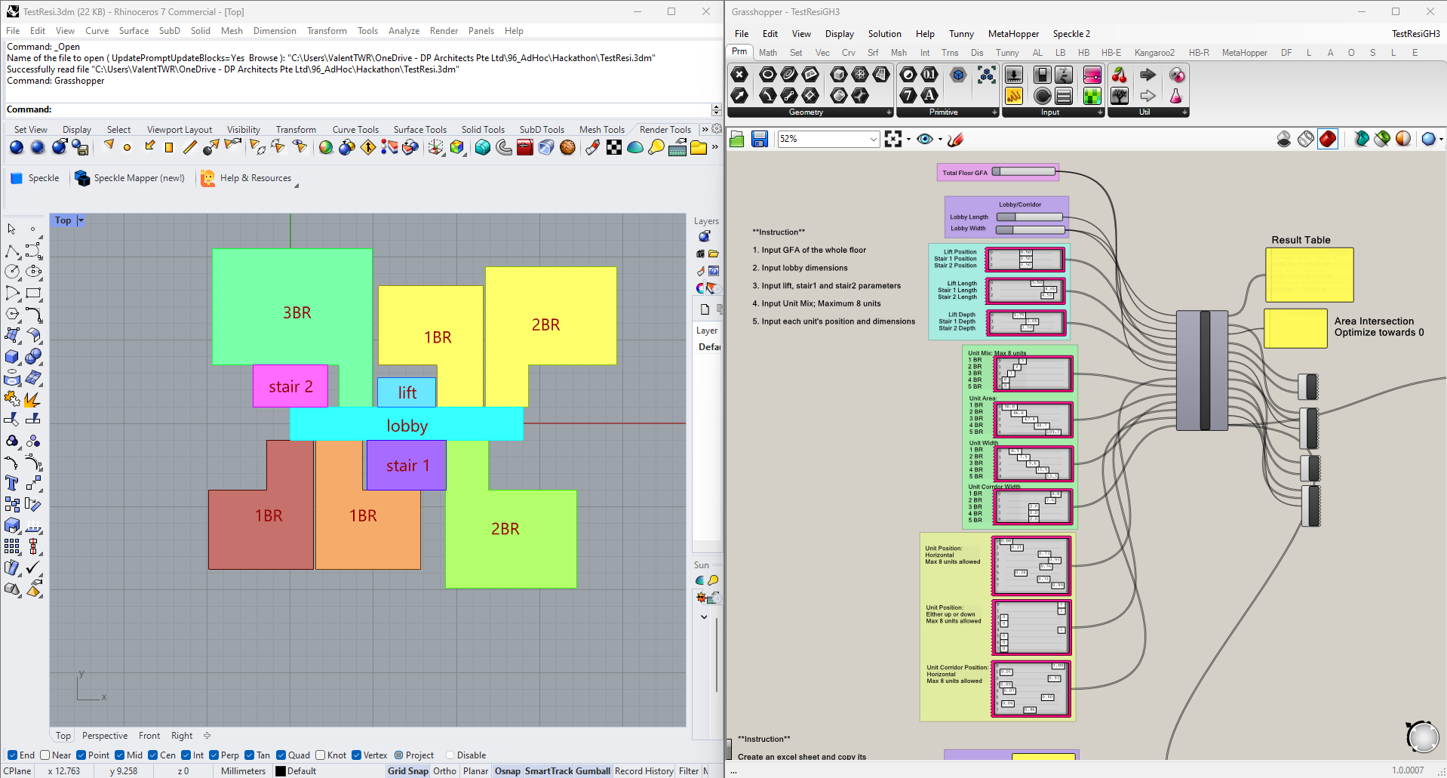
Screenshot of parametric model made on Rhino3D and Grasshopper

Limitations and Strategies
1. Initial limitations are:
- AI model's capability to interpret design requirements and the complexity of measurable parameters. Our strategy to overcome this shall therefore include AI Model Training, User Input Integration, and a Generative Design Process.
- Team is limited in terms of coding capabilities and knowledge of how to run and train an AI/ML model. Our strategy is to extrapolate from other deep learning models to study how we can prepare our dataset and development framework.

2. We set up the parametric model to set constraints, and tested the model based on 2 premises:
- Are we able to meet multiple requirements (efficiency, project brief, authority codes) in an automatically generated typical level floor plan?
- Does the automated floor plan speed up the process of design generation at the feasibility stage?

Tests and Measurements
1. Testing and strategising includes:
- Conducting multiple visual checks on parametric generated model
- Considering varying scenarios and providing more data
- Questioning through group testing
- Refining parametric algorithms based on priorities and necessities

2. Through testing, we learnt the limits of parametric model:
- Highly detailed and many parameters required
- Detailed parameters to be input for a huge number of scenarios
- Conflicting outcomes are generated when parameters are not highly specific
- Model generation time slows down when parameters are too many

- Parameters can only optimise to a limit
  - Detailed parameters based on codes and usual requirement would not be enough.
  - There are designs with waivers and approved based on performances that are only known by domain experts. These are currently not included.

3. Our next phase was to conduct AI training, which revealed the following limits:
- Model could be subject to incorrect training
- Precedent knowledge by domain experts is the way our training model learns
- Large quantity and quality of models to be met to ensure higher robustness in data set
- Heavily subject to time and relevant expertise by training team

- Yet to include external data sets from history
- Years of design for Singapore residential buildings yet to be accounted for, even though they provide information useful for AI knowledge. Can be scoured online
- Some data sets would be outdated or incorrect, requiring further training to identify what is undesirable

What Next
1. Future Strategies
- Expand the AI's capabilities to address increasingly complex and diverse design requirements to include a multi-objectives approach.
- Establish robust user feedback mechanisms for continuous AI model enhancement. User customisation to be made allowable.
- Explore advanced AI techniques such as predictive modelling to further push the boundaries of innovation in architectural design creation.
2. Adaptability and scaling:
- Optimal layout efficiency will remain beneficial and relevant in land scarce Singapore.
- Similar methods can be applied to projects with typical floor plans like hotels and serviced residences. Parameters can be customised and controlled by domain experts e.g. Architects, based on the latest relevant codes.
- Can be scaled down into individual unit layout to get the most optimised layout, or scaled up into site planning.

3. Future Potential:
- Based on quick generation of efficient designs through AI/computational design, it allows greater consideration of layout possibilities beyond the standard form for residential buildings we tend to produce today. Through this, it will be a lot faster to visualise the extent of possibilities allowable for an adjustable range of efficiencies.
- With time and cost for manpower and effort reduced through more automated computational assistance, more resources can be channelled into innovating excellence for residential buildings, which is a huge market in Singapore and many countries.
4. Discoveries in AI and digital tools that we tested
- Finch3D – allows easy adjustment of interior layout based on size. Not based on local requirements and common local practices, but there are parts within the software that can be learnt and adopted
- Podium by Lendlease – team noted that it is focused on the ability to create automated designs that meet authority compliances for residential and industrial typologies. It is still in its developing phase with not all local requirements programmed in e.g. no provision for sky terraces yet, units are spaced out too far from one another (kinks are not yet accounted for in programme). Based on the latter example, it leads to a longer corridor, hence we find that the software appears to not have accounted for the most optimised efficiency floor layout.

5. Advancements to shape solution into a viable Proof of Concept (PoC) or Minimum Viable Product (MVP)
- With a complex relationship between the input and outputs, a Multilayered Perceptron ANN can be used due to its nonlinear functions, thus able to recognize complex patterns. The current model is only trained on a small simple dataset for a typical unit style, thus advancements in the neural network design has to be flexible and accommodates various type and size of datasets for more complex unit layouts
- A Graph-Based Conditional Generative Adversarial Network (GAN) can be used instead, which uses nodes and vertices to model out the relationship between geometry parameters. The aim is to achieve a high accuracy between the generated and manually designed unit layout to gain more confidence in the AI model so that the Proof of Concept is viable.

Documentation and Records:
- Script and Models to be shown during presentation: https://drive.google.com/drive/folders/15iJIbrw9Tmc4XkcvHfMSAF57E6u4dfcB?usp=sharing
- Training Model files: https://drive.google.com/drive/folders/17h5owePT1gkZwSfjN-Y9nbbol-s8YIgG
- Group discussion board on challenges:
https://miro.com/app/board/uXjVNrL36aQ=/

Draco - Sketching/Collaging to AI Render tool

Human-Enabled AI Design Process
Team 5

Problems and Challenges
There's no denying that generative AI tools like Midjourney and Stable Diffusion have significantly changed the way designers develop ideas and create content. Such tools and workflows are being rapidly adopted in the industry by small, medium, and large firms.

However, most generative AI tools use a text-to-image or an image-to-image model with latent diffusion to generate the content. While this has changed the industry, this is not the way architects/designers typically develop and create ideas. The text-to-image/image-to-image models assume that the user has mastered the English vocabulary to interpret and communicate their intentions to the latent diffusion models, whereas architects and designers much prefer to sketch and collage their design intentions.

Objectives and Impact
We strongly believe that using sketches and collages with AI models enables a human-driven AI design process where architects/designers drive the design ideas instead of constantly clicking the "Generate" button and praying that something amazing comes out.

We aim to develop a tool-agnostic, web-based real-time sketching/collaging tool, that allows architects/designers to add their sketches, or use their digital pen to sketch on the canvas, add images from across the web to collage - and then see their design intent render in any style of their preference in a matter of seconds! Then we leverage AI to also create a good text description of the design outcome based on the generated render and the initial client’s brief. This gives the control of design ideation back to the user with AI being a perfect digital assistant. This workflow can save days, if not weeks, going by the current industry workflow of ideation to sketches to 3d models to final render.

We all agree that design ideation is not necessarily a linear process, and would require a lot of back and forth. Imagine if AI can help us critique the process in real time and provide valuable insights and feedback, highlighting gaps between generated outcomes and client briefs. As a personal digital assistant, AI will enable architects/designers to continually improve their sketches/collages to meet the brief requirement.

Solutions and Tools
Draco
Module 01 - Sketch/Collage to AI Render (Done)
A sleek, user-friendly web interface built using React, Vite, and Tailwind CSS integrating @excalidraw for an intuitive sketching/collaging experience to flesh out design ideas. At the backend, we connect to StabilityAI API to render the image.

Module 02 - AI generated Narrative (Done)
Based on short user input of project information such as location, program, space brief, and the sketches in the canvas, we leverage AI to generate a text narrative of the final render. At the backend, we connect to OpenAI API to generate the text narratives.

Module 03 - AI as a Critique (Yet to implement)
AI will generate a critique highlighting what works, and what’s missing by comparing the generated render to the initial brief including a critique score. This module is yet to be implemented.

Limitations and Strategies
- Limited to sketching tools available within excalidraw.
- Needs more control to exactly stick to the structure of the sketch.
- Limited to building scale interior/exterior use cases for now.

Tests and Measurements
Two design experiments will be set up. One for a building exterior design and the other for an interior design. Selected participants will be invited to test the sketch-to-image generative AI system. A systematic documentation of the sketch inputs and associated images will be documented.

What Next
- Implement Module 03
- Deploy and host the tool for public access
- Provide save options
- Add an iteration timeline for each project

Documentation and Records:
https://github.com/vigneshkaushik/Project-Draco

A working MVP demo of the tool shall be shown during the presentation. Here are a few images of Draco.
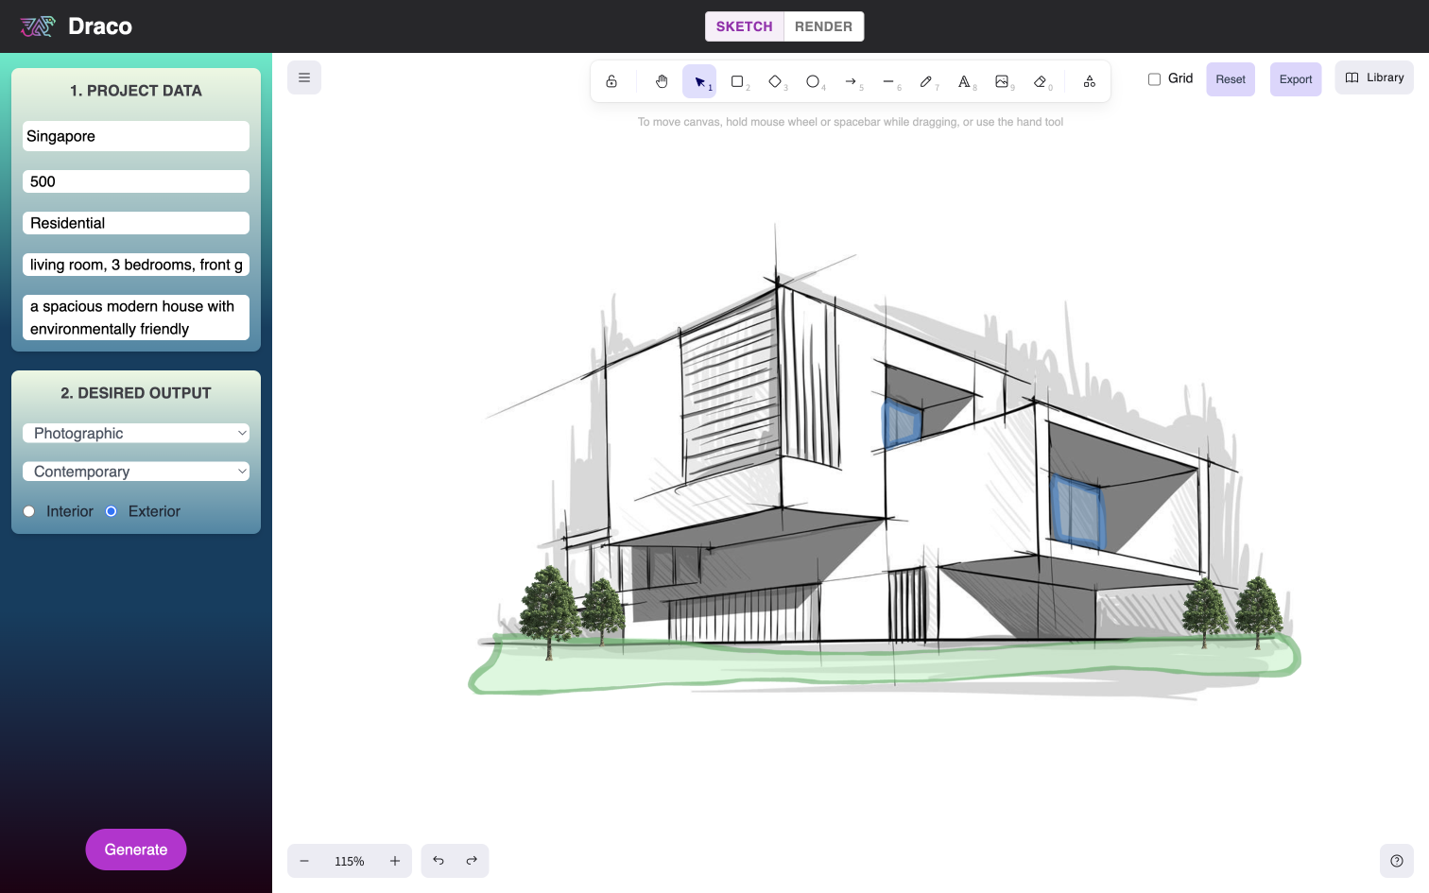
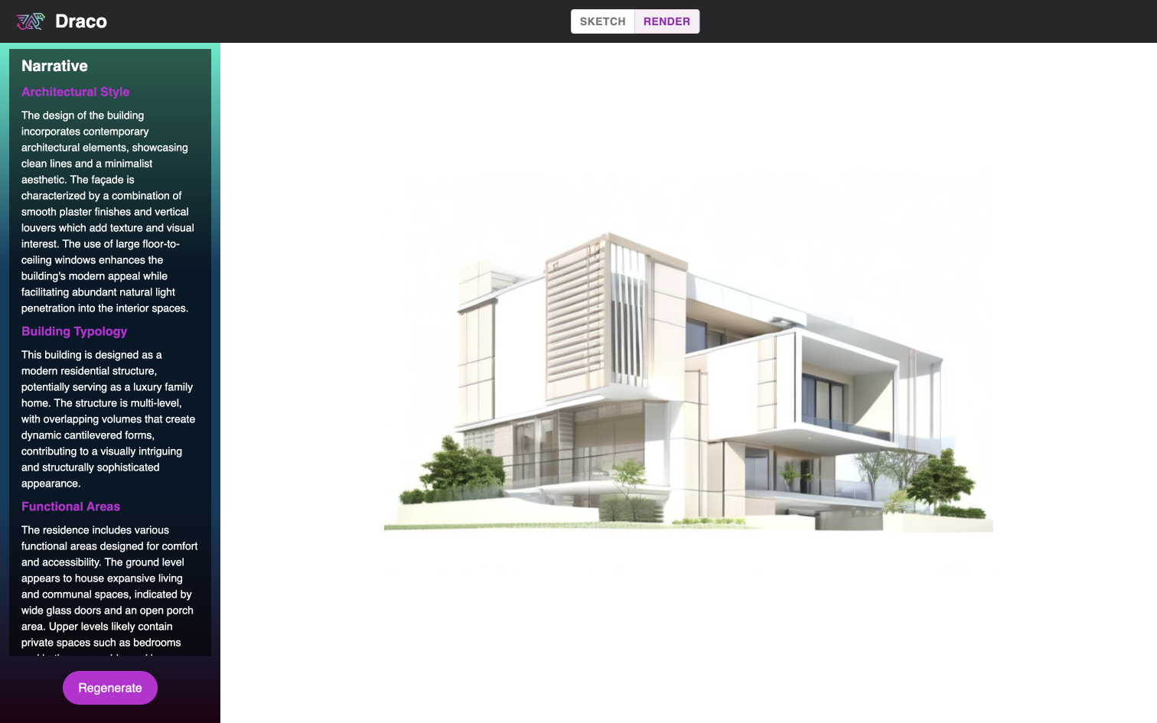

Building Authorities Code Platform
Team 6

Problems and Challenges
For every architectural project, we have to comply with the regulations set out by the relevant authorities. In Singapore, that means having to refer to multiple PDFs, web pages, formatted in all sorts of different ways by different authorities. Having to search and process all these building regulations is time-consuming, and sometimes trying to find the appropriate regulations is like finding a needle in a haystack. Time spent on this “search” activity takes away time from other architectural activities that generate more value for clients and the community.

Objectives and Impact
Our team wishes to do 3 things:

- Learn about recent developments in Large Language Models (LLMs) and Information Retrieval (IR) and their potential roles in the architecture discipline.
- Develop a chat agent that helps quickly retrieve and summarise building code requirements with natural language query by leveraging on what we have learnt.
- Explore various parameters and actions to improve the accuracy of LLMs for Information Retrieval, by:
  - Exploring different data formats
  - Exploring different data indexing strategies
  - Exploring prompt engineering

Solutions and Tools
Retrieval Augmented Generation as Primary Technique
The technique we are using is called Retrieval Augmented Generation (RAG). RAG allows LLMs to access and retrieve data from external sources. In this case, the external source would be the documents that we provide. The advantages of RAG include reducing the possibility of hallucinations, the possibility of citing sources, and reproduction of the text from external sources verbatim, allowing for greater levels of trust in an LLM’s responses.

LlamaIndex as Data Framework
We will be using LlamaIndex as the data framework. LlamaIndex is a data framework for LLM-based applications which benefit from context augmentation. LlamaIndex’s abstractions allow us to quickly adapt our implementation to use various LLMs and techniques as they are released, and would allow us to keep up with new developments. The techniques that we will explore with LlamaIndex are:
- Regarding Data
  - Data Formatting - Ensuring the data is formatted into computer-readable formats
  - Data Splitting - Splitting large monolithic documents into relevant “chapters”, “sections”, “clauses”, etc
  - Data Corrections - feeding corrected Q&A samples
- Regarding Indexes
  - Selection of relevant embedding models
  - Adjusting embedding dimensions - lower dimension values are more efficient and good enough for simple texts, higher dimension values are more computationally expensive but may be required for complex texts. Higher dimension values seems to also cause the retrieval of information that is too distantly relevant to the query.
- Prompt Engineering
  - Zero-shot Chain-of-Thought - “Let’s think step by step” seems to increase reasoning capability of LLMs
  - Generated Knowledge - the use of generated knowledge (by the LLM) to make a prediction or give an answer
  - Self-Consistency - sampling of diverse reasoning paths to select the most consistent answer
- LLMs
  - LLM selection - certain models perform better on certain tasks
  - Chat Engine configuration - LlamaIndex specific configuration of Condense-Context, that utilises a multi-step processes of condensing the query, retrieving relevant context, and then passing the context, with the prompt, and user query, to the LLM for response generation

LLM Services
Using the LlamaIndex Framework, we will run our tests across these LLM services:
- OpenAI ChatGPT (3.5 and 4 turbo)
- Anthropic Claude
- Google Gemini
- MistralAI

Limitations and Strategies
Solved Challenges: Primary Challenge - Prompt Engineering
Without a properly structured prompt, LLMs tend to give unstructured responses, incomplete information. Such issues can easily be improved by prompt engineering, the art of giving instructions to LLMs. We explored a few techniques such as Zero-shot Chain-of-Thought, Generated Knowledge, Self-Consistency to get more structured responses, and more complete information. Here are a few instances of how that helped:

Adding this line to the prompt “You must always first provide the clauses, their titles, and their description that are relevant to the query. They must be provided verbatim.” causes the LLM to always response with an indication of the Clause numbers, and a verbatim extraction of the clause description from the code. Adding HTML tags such as “<a href=’{{ link to clause }}’>Clause number</a>” works some of the time as well to include dummy links to a currently non-existent online reference to the BCA approved doc.
Adding this line to the prompt “Let’s think step by step” as seen in the paper Large Language Models are Zero-Shot Reasoners, often helped to provide more comprehensive answers.
Within the prompt, including a line to first retrieve the relevant code clauses first, generate the answer based on that, and then formatting the answer into a specified format seems to perform much better than asking for the answer in a specified format directly. This correlates with the findings in the paper Generated Knowledge Prompting for Commonsense Reasoning.

Solved Challenges: Secondary Challenge - Data Corrections
The responses we were getting were still erroneous in some areas, particularly in areas where phrasing of the code leads to some ambiguity, or where interpretation of the code requires some form of inference. In addition, there are many contextual considerations, or unmentioned regulations that are simply not mentioned in the building code documents.
We found that this can easily be resolved by letting trusted users input additional data to the indexed datasets of Building Code in the form of Question and Answer pairs. The LlamaIndex framework used allows us to add or remove additional data on-the-fly to the original dataset.

Such functionality can possibly be expanded on in the future to include the input of contributions from the larger architectural community on interpretations and knowledge of the Building Code, to allow for collective building of knowledge that can also be accessed by LLM chat agents.

Unsolved Challenges: Primary Challenge - Good Data
LLMs, or rather, AI in general, require good data to give good results. “Good” data, is data that is:
Formatted in a manner that allows for accurate retrieval and parsing in whole, by the computer.
Contextual. The data should be associated with additional data, usually in the form of metadata, that gives additional context to its meaning.
Explicit/ unambiguous. The data, particularly text, should be as clear as possible about its message.

The primary challenge we had in our process is acquiring good data. Building codes from various agencies are presented in vastly different structures and formats, that may or may not allow for accurate retrieval and parsing in whole by computers. A prominent example of this is the ubiquitous pdf format - while a great format for portable, human-readable documents, when parsed by a computer they often present broken-up sentences and text that is out of order. The same happens with tables in pdfs - the order of rows and columns are sometimes incorrectly extracted. This often results in the retrieval of wrong information by the LLM.

A basic solution to such a challenge would be to manually reformat the building codes into a human and computer-readable format, such as properly annotated markdown or JSON format. However, such an endeavor would be manpower intensive to start, and also to update as new building codes are released/updated periodically. A more feasible solution would be for the various government agencies to adopt a standardised, uniform interface for Building Code data. This would be a consistent way to retrieve, update, depreciate Building Code Data amongst Govt Agencies, enabling immediate updating of databases that LLM applications and other web applications can utilise. The technology already exists - this is what is required:
A shared schema for all building code that is both human-readable and computer-readable
Common databases of all building code with access via a REST Api
Cross-agency collaboration on building code

Unsolved Challenges: Secondary Challenge - Large Datasets, and Hierarchical Chat Frameworks
In our testing, LLM Chat Agents struggle with large datasets (eg. BCA Approved Doc + SCDF Fire Code 2018) despite the techniques we have applied above. No amount of document splitting, document formatting, prompting could solve accuracy issues. We also run into token limitations.

A possible solution to this would be to look at using multiple agents instead of relying on a single agent. In the paper Navigating Complexity: Orchestrated Problem Solving with Multi-Agent LLMs, researchers proposed using an “orchestrating” LLM to first interact with the user to understand the query, decompose the query into tangible sub-problems, then assigning each sub-problem to specialised LLMs. The orchestrating LLM then compiles the various answers from each specialised LLM into a response for the user. Such a task decomposition approach avoids the constraints imposed by token limitations, but also allows LLMs to output nuanced, accurate responses to complex and ambiguous problems.

We can look to adopt such an approach, as a hierarchical chat framework, making use of a similar orchestrating LLM to decompose, delegate, and compile responses to provide more detailed responses to generic queries about the building code. This would allow for users to query across various agency building codes to give a more complete picture of the considerations for compliance required.

This would require quite a lot of work to be built, but can be done in time.

Unsolved Challenges: Tertiary Challenge - Multi-Modal Data and Queries
Many documents in Singapore’s building code contain images and diagrams, which illustrate a lot of information that is otherwise not mentioned in text. The current implementation of our chat agent does not have the ability to process such images and diagrams in the data, nor are they able to process queries in those formats. Having such an ability would prove very useful to a building code chat agent, as it would give a more comprehensive dataset, but also allow architects to query by sketches.

Such features have only been possible in the past couple of weeks, we will continue to explore this area.

Tests and Measurements
Test Case 1: Converted the version number 7.05 to 7.5 to better conform with software management standardisations (Semantic Versioning Specification). Chatbot answers were more accurate.

Test Case 2: Separated documents into individual clauses. This likely allowed the LLM to receive less data to process, reducing the need for the LLM to sieve through unnecessary information. Chatbot answers were more accurate.

Test Case 3: Provided corrected / additional information through an additional document. Chatbot was able to retrieve and answer from additional documents.

We have determined that we are not able to adequately measure the efficiency increase as different people use different methods for retrieval of information (e.g. opening and searching digital code on pdf or websites, hard copy printouts, etc.), however we agree that using this method will free up mental load to users as there is no need to focus on finding files or text, just by typing their query the answer can be retrieved.

The chatbot can also be used in other ways including as a training tool for learners to test their knowledge with queries.

What Next
Advancements can come in the following forms:

1. Quick reference Chatbot that can be continuously refined through community feedback.
2. Better formatting and standardisation of future code releases.
3. Developing a Chatbot that can help convert future code releases to the proper format.
4. Developing a Chatbot in which through providing parameters of the project, generate a checklist of code requirements specific to project parameters.
5. Developing a Chatbot that can interpret the code for special situations by referencing past case studies and examples from overseas.

Documentation and Records
- https://www.youtube.com/watch?v=TRjq7t2Ms5I&ab_channel=AIEngineer
- https://up.codes/

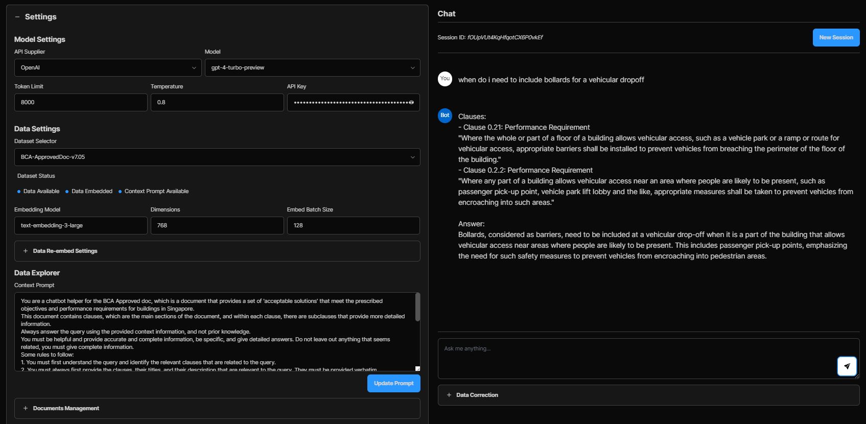

Automated and Intelligent generation of Massing Models and Visualisation from Design Brief
Team 7

1. Introduction: The routine of understanding Design Briefs
Every architectural project begins with a design brief which needs to be distilled to extract key parameters for design conceptualisation. This is a mundane and routine task for every project but essential in order to have an overview and understanding of the scale and complexity of the project. This informs architects and other project members of the scope of works and inform them of how much fees to quote. The speed with which this is done is particularly important when doing feasibility studies and design competitions.

1.1 The Problem and Challenges:
- Design briefs are provided in various formats and are often extremely lengthy pieces of text
- They have varying degrees of fixed and variable parameters
- Architects have to spend time to peruse the design brief and come up with basic data followed by incorporation of relevant planning parameters
- Takes time to digest and process information to come up with a basic massing model that helps to visualise broad massing and overview of the project based on information at hand
- This is a mundane and routine task for almost every project but is done manually that takes a lot of time and effort

1.2 Objectives and Impact:
- To use Generative Artificial Intelligence (gen AI) for a technological solution that automates this task
- Use of AI to instantly pick key data from various design briefs into a standardised format
- Use of AI to automatically refer to relevant regulatory requirements and apply basic planning parameters
- The solution passes retrieved data and applicable planning parameters to modelling program to generate a quick massing model
- If a particular architectural style is mentioned in the brief, the solution passes it to a diffusion model to generate a quick render on the massing model for that style

2. Crafting the Solution
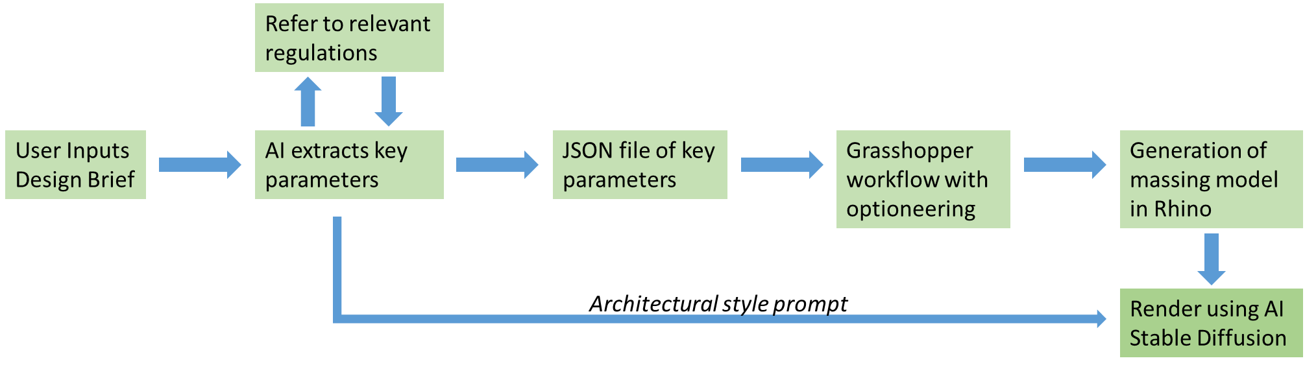
Figure 1: Solution Workflow

2.1 Solutions and Tools
Tools used:  - Botpress – A ChatGPT chatbot powered by the latest in LLMs and GPT by OpenAI  - Rhino+Grasshopper – Rhino is a 3D modelling program that allows quick generation of 3D models. Grasshopper is a visual programming language and environment that runs within the Rhino 3D computer-aided design application  - Stable Diffusion – A deep learning, text-to-image model based on diffusion techniques | Inputs required:  - Design Brief  - Site boundary in closed planar polyline
Steps:
- Botpress interfaces with the user – architect or developer. Asks the user to input a text based design brief
- The ChatGPT AI in Botpress retrieves key data from the design brief such as development type, unit mix, unit areas etc.
- Based on the development type, the AI is tasked to look up for relevant planning parameters from regulatory website such as URA residential/non-residential handbooks
- The AI extracts applicable parameters such as setbacks, floor-to-floor height, max floor area etc and generates a JSON file of key parameters
- This JSON file is passed onto Grasshopper. The user selects a file consisting of the site boundary in a closed planar polyline such as a dwg file.
- Grasshopper generates a 3D model in rhino based on the site polyline and retrieved parameters
- Grasshopper sliders allow quick optioneering of the generated massing within the applicable parameters
- Chosen option with best view is passed on to stable diffusion
- Any architectural style mentioned in the design brief is retrieved by Botpress and passed on to Stable Diffusion as a prompt to generate a quick render
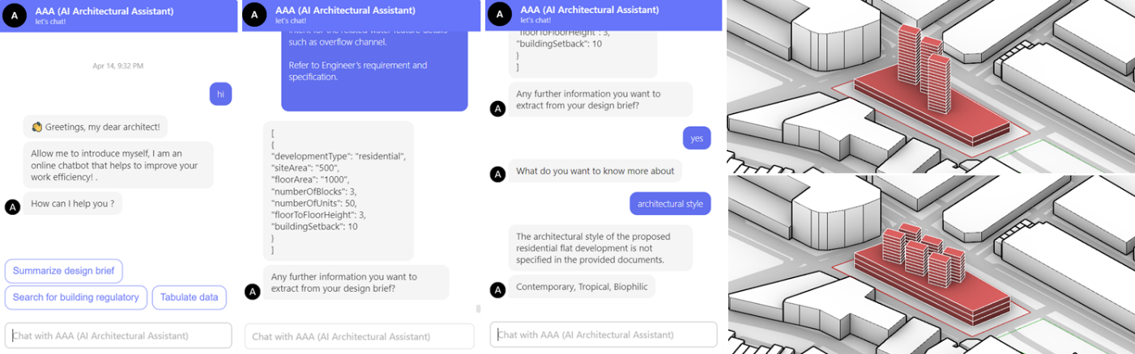
Figure 2: Screenshots of AI chatbot and created massing models

2.2 Limitations and Strategies
The current version of the solution is a simple proof-of-concept that relies on sufficient information in the design brief and availability of regulatory requirements online. If the design brief does not have certain information, the AI assumes the best fit information. In Singapore, regulatory information from agencies such as URA, BCA, SCDF, NEA, PUB, LTA, NParks are easily available online in their websites or as pdfs within their websites.
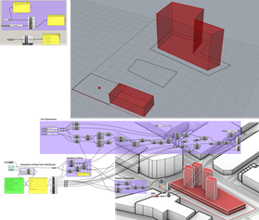
However, the interpretation of the codes is still subjective and in complex scenarios such as mixed-use developments, the AI may fail to accurately determine the parameters necessary. Human intervention may be necessary in such scenarios. One strategy to address this is if the AI chatbot finds difficulty in determining the correct parameters, it can further ask the user to clarify. Another strategy is to provide more options within the grasshopper workflow to allow the user more flexibility to adjust or correct any errors made by the AI.

2.3 Tests and Measurements
Our team started with a small test case and incrementally added complexity to generate the Minimum Viable Product (MVP). First, we generated a rhino model using few parameters extracted from a design brief using a ChatGPT text prompt. Subsequently, we tested getting the AI to refer to regulatory requirements through external links. Using Botpress, a user facing AI chatbot was created to interact with the user. The grasshopper workflow was expanded to work with more pieces of data and also include optioneering provisions with sliders. This met the objective of giving a quick massing model and broad overview of the project. Finally, a scene output to stable diffusion was considered for rendering of a particular style.
Figure 3: Testing and scaling up of solution

2.4 What Next
To look into industry implementation of this solution, it needs to scale up to meet the plethora of real-world requirements. This scalability will include the following
- To determine more fine-tuned design parameters, AI and machine learning can be used to understand client design briefs in more detail and apply more granular design and regulatory requirements such as corridor widths, determination of staircase requirements, determination of toilets to come up with more detailed massing models
- AI and machine learning can also be used to pick best or most efficient layout based on a hierarchy of preferences. AI and ML can produce multiple options of the model based on preferences
- For it to be versatile, uploaded regulatory requirements can be categorised by jurisdiction such that the solution can be used globally
- Site boundaries can be directly drawn over on Google Earth
- Plugin scripts can be developed that can work on top of the generated massing model such as a script to generate façade or a script that creates a parking layout. There can be addition of more stylistic options as well
- The entire solution can be linked to BIM software such as Revit or ArchiCAD with IFC-SG information incorporated for further development of the design
- Iterative development with multiple stakeholders and interoperability with multiple programs will allow the solution to be used from beginning to the end of entire project cycles. This will require an easily accessible and versatile interface such as on the web or through an app.

2.5 Documentation and Records
Upon completion of development, a website can be set-up for users to download necessary data, programs, information and manuals. Video tutorials on youtube can also be provided.
More info: Workflow Documentation, https://mediafiles.botpress.cloud/79b0c192-7acd-4d94-a90f-7a595a7fae6c/webchat/bot.html

Quick Carbon Calculator

Full Cycle Carbon Calculator
Team 8

Problems and Challenges
- It is hard to get overview data about any existing structure’s Full Carbon Lifecycle footprint due to the lack of data and the complexity of calculation involved.
- Most designers, developers and owners have no idea how to arrive at such a number which allows them an overview of the impact of their operational carbon as well as potential embodied carbon emissions of the existing structures (if the building was to be taken down)
- Estimating precise material composition of buildings are often left to specialists and different trades, depending on the type of reporting required based on regulations.
- There is no open data source or calculator that allows any quick overview of the data of full cycle carbon for any building as data has to be input from Embodied Carbon and Operational Carbon

Objectives and impact
Using the NLP abilities to sieve through large amounts of data, allows a system to quickly get information and process calculations on-demand. Through a trained database of ICE data, Energy Usage Data as well as Building Data we can able to estimate Existing Building’s Full Carbon Life Cycle instantly through an LLM interface.

This tool will provide an estimated full-cycle carbon footprint for buildings to developers, owners, and designers, helping them understand the environmental impact of their existing structures.
Functional Overview:
With input of the building's name and location, the calculator estimates:
- Embodied Carbon - total carbon cost of materials and construction processes.
- Operational Carbon - ongoing emissions from building operations.
- Carbon Sequestration Needs - number of trees required to offset the calculated carbon over the building's lifecycle.

Process and Data Workflow
Step | Task | Process | Data Required | Outcome
1 | Get Building Data | Use OpenStreetMap API to extract building details. If unavailable, use internet assumptions or direct user inputs. | Building name, location, number of floors, basement levels, constructed floor area | Confirmation of building details; user corrects if inaccurate.
2 | Get Building Material Data | Identify key materials used (concrete, steel, glass). Data taken from ICE database to correlate materials | Estimated percentage of each building material used | Confirmation of building material estimates.
3 | Calculate Embodied Carbon | Input building material data to estimate carbon footprint from construction materials. | Data on carbon output per material | Embodied Carbon estimate.
4 | Calculate Operational Carbon | Use EMA data of Carbon Use based on the year of EUI estimated to get Operational Carbon. If unavailable, to estimate based on typology and area from the search tool. | EMA carbon use data, EUI data | Operational Carbon estimate.
5 | Calculate Carbon Sequestration | Sum embodied and operational carbon to determine total emissions. Calculate the number of trees required to offset these emissions over the building's current lifetime. | Total calculated carbon emissions | Carbon sequestration strategy in terms of tree planting.

Challenges and Strategies
- Data Accuracy and Availability:
- Limited to reported information of existing buildings under compulsory reporting; lacks comprehensive coverage across all building types.
- Absence of a unified database for embodied carbon; reliance on disparate sources and approximations from prior studies complicates accuracy.

- Technological Adaptation and Resource Constraints:
- While ChatGPT offers a user-friendly interface, ongoing enhancements are necessary to maintain relevance with advancing AI capabilities.
- Requires OpenAI Plus subscriptions, which may limit access for users without the means to afford premium services.

- Privacy and Data Security:
- Uncertainty regarding future policy changes by OpenAI could affect how input data is handled or utilised.
- Need for stronger guarantees on data privacy and security to build trust and ensure compliance with global data protection regulations.

What Next
- Improved Data Collection and Integration:
- Develop partnerships with regulatory bodies and construction firms to access a broader dataset, including residential and unreported buildings.
- Aim to create a centralised repository for global embodied carbon data to standardise calculations and improve accuracy.

- Advanced Calculation Capabilities:
- Develop more precise formulas for real-time calculations of building characteristics, such as the floor-to-window ratio, which are critical for accurate carbon footprint assessments.
- Integrate machine learning models to refine estimations of material impacts based on ongoing global research and updated environmental standards.

Documentation and Records
- ChatGPT – The LLM is able to be found on ChatGPT store as a plugin to be used (Plus account required)
- Google Slides: Presentation detailing features and benefits.
- Google Doc: In-depth guide on using the calculator, including step-by-step processes.

Screenshots
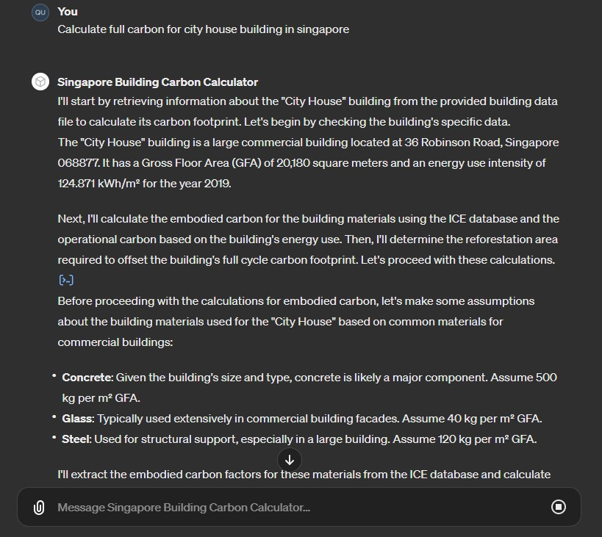
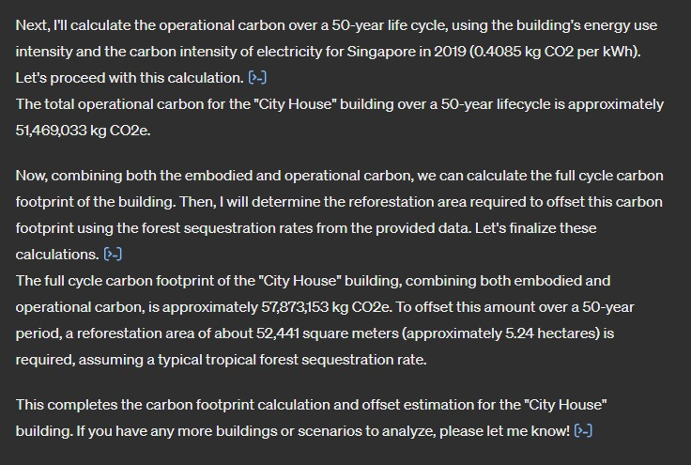

Design Change Identification
Team 9

Problems and Challenges
During the construction phase, variations may arise for various reasons, including site conditions, regulatory compliance, or shifts in client preferences. Even after design updates, documenting these changes still necessitates manual effort to ensure precise cost estimation and on-site instructions. This typically entails detailing each altered item, specifying modifications in materials, dimensions, or other relevant specifications.

Objectives and Impact
The objective is to develop an automated system for identifying design changes by comparing tender drawings with amended drawings. The system will list differences, emphasising updated dimensions, new materials, or additional building elements like doors or windows.

Each Request for Variation Order (RVO) necessitates approximately one hour of the architect's time to meticulously examine each drawing, pinpoint variances, and meticulously document each detail. With an average of 100-200 RVOs per project, this approach holds the promise of conserving around 200 man-hours, considering that certain RVOs are prepared but ultimately not needed for approval.

Solutions and Tools
Compare changes from PDF drawings
Step 1: Auto comparison of drawings
- Scale - make sure both drawings are to scale
- Compare - identify and highlight changes
- Count - assign unique identity to each change
Step 2: Auto-generation of texts and description from the image
- Database - Gather a database of drawing representations with description
- Identify - Train the model to identify building elements from drawing
- Measure - Quantify the amount of dimension of each change
- Document - List all unique changes and the corresponding descriptions

Limitations and Strategies
- Drawing styles depend on authoring software: to solve this, a standardised PDF format is used to eliminate the compatibility issues and reduce the file sizes involved.
- Building elements are simplified in drawings resulting in some elements to appear very similar to others such as stairs and walls.

Tests and Measurements
Typical scenarios of design changes will be tested

What Next
- Discuss the future potential and adaptability of your solution to new conditions
  - This system can be further developed to automatically include the reasons for the changes and have automatic measurements for easier costing and site instruction

- Discoveries in AI and digital tools
  - Python, YOLOV8 Image detection machine learning

- Consider advancements that can shape your solution into a viable Proof of Concept (PoC) or Minimum Viable Product (MVP), focusing on key functionalities and feasibility.
  - Comparing differences between drawings has the potential for other applications such as tracking changes to a building over time, preparation for A&A works especially for older buildings not modelled in BIM or even spotting discrepancies between drawing versions.
  - The differences between drawings can also be used for costing purposes to evaluate the cost difference between various design options.
  - Ready trained data sets used for other design and construction applications

Documentation and Records
Documentation using GitHub, Streamlit.
https://object-detection-from-plan-drawings-2wv5vdvcfmezpgjxkixjbq.streamlit.app/YOLO_for_plans

Presentation Slides.
https://docs.google.com/presentation/d/1NlYgJkV-Ma3LA47VO6c5FvEDeBX8Q-63/edit?usp=sharing&ouid=105880087364338848324&rtpof=true&sd=true

Learning Guide:

Architectural Design Quick Ideation and Visualisation with Generative AI
Team 10

Problems and Challenges
Consultants are often challenged by demanding requirements with tight deadlines, rapid technological advancements requiring quick adaptation, and the need to close skills gaps and enhance competency.

- Demanding requirements with tight timeframe: Clients' high demand for quality visualisations and architectural renderings with frequent imposed changes and iterative design studies is challenging for consultants to deliver quality work within tight deadlines.
- Rapid Technological Advancements and adaptation challenge: Rapid advancements in technologies such as Generative AI pose a significant adaptation challenge, especially for SMEs with limited resources. This situation not only impacts their ability to stay competitive but also risks widening the gap between small and large consultancy firms.
- Skills Gaps and Competency building: Firms that do not keep pace with technological changes face the risk of becoming outdated and falling behind their competitors. Moreover, the gap between firms able to invest in new technologies and those that cannot highlights the urgent need for competency building to keep smaller players competitive.

Objectives and Impact
The project aims to address the challenge of creating user-responsive architectural design ideations and visualisations by exploring Generative AI tools and providing accessible learning resources shared among the community of practice.

- Use of Generative AI (GenAI) Tools for Quick Ideations and Visualisations: By engaging GenAI tools for architectural ideation and visualisation, e.g. Midjourney for quick generation of architectural ideas and visuals, and the use of Stable Diffusion with ComfyUI for specific architectural design style, may effectively and quickly create user-responsive designs.
- Understanding of the GenAI using Quick Learning Guides: The developed quick learning guides may serve as a quick reference for consultants to quickly apply techniques and strategies used in Midjourney and ComfyUI.
- Online sharing among the Community of Practice: We have developed and distributed learning guides with use cases and know-how sharing to address the skill gaps in Gen AI use. In addition, we have shared online posts in blog format to disseminate available learning materials.

Solutions and Tools
The solutions involved online and local Generative AI tools using custom datasets, gathered practitioner feedback on time and effort savings, and used techniques with massing models to enhance design accuracy and meet development needs. A Guide was developed and shared openly.

- Online Platforms: Online GenAI tools like Midjourney and Promeai offer quick design exploration and ease of access, ideal for initial brainstorming and generating design ideas.
- Locally-Run Options: For more control and cost-efficiency, practitioners can leverage locally-run setups like Stable Diffusion with ControlNet on high-spec servers or machines for local computing power.
- AI Model Training for Diverse Design Styles: Implementing AI model training techniques to enable the development of different architectural design styles tailored to specific project requirements. This approach enhances flexibility and creativity in the design process, allowing for the exploration of various aesthetic directions and blending of different approaches using own datasets.
- Using a massing model as a base to Improved accuracy generated by GenAI: To enhance design accuracy, a simple massing model can be created by using a modelling tool, e.g. sketchup, Rhino, Blender or etc., to export the massing model’s sketch lines or the depth maps to guide the GenAI Tool for precise design iterations.

Limitations and Strategies
Generative AI exploration challenges, including spatial understanding issues, Intellectual Property (IP), data bias, and limited training resources, can be addressed through strategic approaches like using sketch outlines for spatial accuracy, developing proprietary datasets, defining user-specific requirements, and fostering a community of practice for knowledge sharing.

- Lack of Spatial Relationships’ Understanding: GenAI often struggles with accurately interpreting and generating spatial relationships and dimensions. To address this, Practitioners can use sketch outlines or depth map files generated from a massing model, to serve as a base for GenAI outcomes and subsequent developments and modifications.
- IP Concerns: Using closed-box datasets in GenAI can raise IP issues and potentially limit the commercial use of generated designs. To address these concerns, Practitioners can develop and use their own datasets for creative outputs.
- Data Bias and Availability: GenAI outcomes are constrained by the diversity and quality of datasets, often struggling to meet specific architectural visualisation needs like tropical architectural contexts. Practitioners can address these shortcomings by defining their own specific requirements.
- Limited Training Resources and Local Experts: The limited availability of GenAI courses tailored for Architectural Design, along with few local expert guidance and resources, makes self-driven learning challenging and time-consuming for practitioners. Practitioners may share their experiences and grow the community of practice, which can be beneficial for building their profiles and potentially gaining insights from experts.

Tests and Measurements
We tested tools like MidJourney and promeai for rapid ideation, customised model training with datasets on Brutalism and Modern Tropical Styles, and addressed IP issues and precision for engineering drawings using GenAI.

- Rapid Ideation and Visualization: We have tested the use of MidJourney (https://www.midjourney.com/) and promeai (https://www.promeai.pro/) that enable practitioners to quickly generate and iterate over multiple design concepts based on textual prompts. This facilitates rapid visualisation and refinement of ideas, allowing for swift explorations of different architectural design iterations and modifications without having to build detailed models and going through rendering software setups.
- Customised Model Training: We explored Lora model training with datasets, including Brutalism and Modern Tropical Styles, finding that practitioners can customise datasets to reflect specific aesthetic principles. For instance, saving 25 images in safetensor format enables the Gen AI engine to produce style-specific outcomes. This specialised dataset training ensures faithful representation of architectural styles, leveraging proprietary datasets for refined results.
- Feedbacks and Concerns: We've shared our approach with colleagues and practitioners, who find that using GenAI tools saves time and effort but raises IP concerns with closed-box data. Some express doubts about using AI-generated images for detailed project development and documentation, as Gen AI solutions currently lack the precision for engineering drawings.

What Next
We will explore different AI tools, customised Model datasets, and integration with BIM software for design refinement.

- Explore different AI tools and GenAI model training: Compile and assess various AI tools for industry awareness, and broaden model training to include diverse building types and tropical designs for architectural projects
- Extend GenAI to engineering and tender drawing production through BIM integration: Explore linking GenAI's with BIM software to automate drawing generation using predefined BIM modules for rapid detailing and design refinement.
- Explore topic-focused hands-on activities: Engage industry partners in hands-on AI / Gen AI activities and trials to build digital competency and foster community growth.

Documentation and Records (Links):
- Google Slides (Presentation)

Jerry Liu, “LlamaIndex,” Python, November 2022, https://github.com/jerryjliu/llama_index.
Takeshi Kojima et al., “Large Language Models Are Zero-Shot Reasoners” (arXiv, January 29, 2023), https://doi.org/10.48550/arXiv.2205.11916.
Jason Wei et al., “Chain-of-Thought Prompting Elicits Reasoning in Large Language Models” (arXiv, January 10, 2023), https://doi.org/10.48550/arXiv.2201.11903.
Jiacheng Liu et al., “Generated Knowledge Prompting for Commonsense Reasoning” (arXiv, September 28, 2022), http://arxiv.org/abs/2110.08387.
Xuezhi Wang et al., “Self-Consistency Improves Chain of Thought Reasoning in Language Models” (arXiv, March 7, 2023), https://doi.org/10.48550/arXiv.2203.11171.
“Chat Engine - Condense Plus Context Mode - LlamaIndex,” accessed April 14, 2024, https://docs.llamaindex.ai/en/stable/examples/chat_engine/chat_engine_condense_plus_context/.

